General Information
PICTURE | 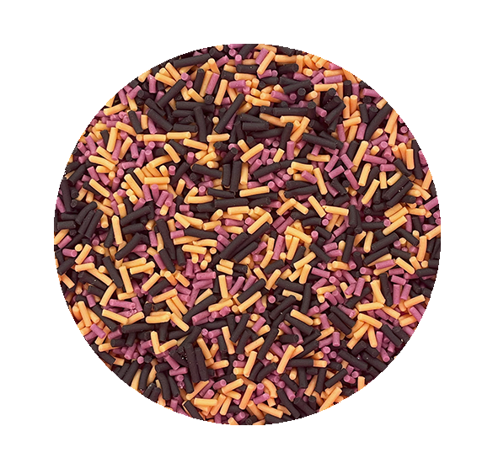
DESCRIPTION | Halloween strands 1.2mm diameter 4-6mm long, Black, Orange, Purple coloured sugar sprinkles.
SKU CODE | SPR-HSTR-GL
SPEC NUMBER | SP0094
LEGAL DECLARATION when used in isolation according to EU regulation 1333/2008 & Commission directives 231/2012 & 1129/2011 | Sugar Decorations
INGREDIENT DECLARATION | Sugar, Rice Flour, Sunflower Oil, Potato Starch, Colour (Radish, Blackcurrant, Apple, Safflower, Lemon, Spirulina, Carbon Black (E153)), Flavouring (Natural Vanilla Flavouring).
RAW MATERIAL COUNTRY OF ORIGIN | Spain, Germany.
COUNTRY OF MANUFACTURE | Spain
SHELF LIFE & STORAGE INSTRUCTIONS | Two years from manufacture, store in a cool dry place, maximum recommended temperature 35॰C
APPLICATIONS | Sugar decoration
DOSAGES RECOMMENDED | As required

Microbiological Limits
TEST | MAX LIMIT |  | FREQUENCY OF TESTING
TVC | Not tested |  | NA
Yeasts | 300 Cfu/g |  | Every batch
Moulds | 300 Cfu/g |  | Every batch
Enterobacteriaceae | 100 Cfu/g |  | Every batch
E Coli | 10 Cfu/g |  | Every batch
Salmonella | Negative in 25g |  | Every batch
Coliforms | Not tested |  | NA
Listeria | Negative in 25g |  | Every batch

Organoleptic and Quality

Product Characteristic
Defective parts maximum 5%, Hard, Sweet, Free from off flavours and smells

Foreign Body Controls e.g.Metal Detector/X-Ray/Sieve

Control Type | Detection limit | Frequency
Metal detector | 2.5mm Ferrous | Every pouch
Metal detector | 2mm Ferrous, 2mm Non-ferrous, 2mm Stainless | All finished product
Filter | 6mm | All finished product

Physical Properties

Physical Property | Limit | Testing Frequency
PH | <4.6 | Yearly
AW | <0.6 | Yearly
Moisture | 1.6% | Every batch
Ethanol Content | NA | NA

Nutritional Information per 100g
Energy | 1756 | KJ
Energy | 414 | Kcal
Carbohydrate | 95.00 | g
Of which sugars | 87 | g
Fat | 4 | g
Of which saturates | 0.31 | g
Protein | 0.5 | g
Fibre | 0.5 | g
Salt | 0.011 | g

Allergen Information

Does the product contain any of the following, including any possible source of cross contamination or carry over?
Allergen (Directive EU 1169/2011 Annex II) | Present in Product | Used on site | Used on Shared Equipment | Risk of contamination (Y/N)
Cereals containing gluten, namely: wheat, rye, barley, oats, spelt, kamut or their hybridised strains, and products thereof, except:  - wheat based glucose syrups including dextrose  - wheat based maltodextrins  - glucose syrups based on barley;  - cereals used for making alcoholic distillates including ethyl alcohol of agricultural origin; | N | Y | N | N  (Used on supplier site in finished goods, packed using separate dedicated equipment)
Crustaceans and products thereof | N | N | N | N
Eggs and products thereof | N | Y | N | N  (Used on supplier site in finished goods, packed using separate dedicated equipment)
Fish and products thereof, except:  - fish gelatine used as carrier for vitamin or carotenoid preparations;  - fish gelatine or Isinglass used as fining agent in beer and wine; | N | N | N | N
Peanuts and products thereof; | N | N | N | N
Soybeans and products thereof, except  - fully refined soybean oil and fat  - natural mixed tocopherols (E306), natural D-alpha tocopherol, natural D-alpha tocopherol acetate, and natural D-alpha tocopherol succinate from soybean sources;  - vegetable oils derived phytosterols and phytosterol esters from soybean sources  - plant stanol ester produced from vegetable oil sterols from soybean sources; | N | Y | N | N  (Used on supplier site in finished goods, packed using separate dedicated equipment)
Milk and products thereof (including lactose), except:  - whey used for making alcoholic distillates including ethyl alcohol of agricultural origin;  - lactitol; | N | Y | N | N  (Used on supplier site in finished goods, packed using separate dedicated equipment)
Nuts, namely  almonds (Amygdalus communis L.), hazelnuts (Corylus avellana), walnuts (Juglans regia), cashews (Anacardium occidentale), pecan nuts (Carya illinoinensis (Wangenh.) K. Koch), Brazil nuts (Bertholletia excelsa), pistachio nuts (Pistacia vera), macadamia or Queensland nuts (Macadamia ternifolia), and products thereof, except:  - Nuts used for making alcoholic distillates including ethyl alcohol of agricultural origin | N | N | N | N
Celery and products thereof | N | N | N | N
Mustard and products thereof | N | N | N | N
Sesame seeds and products thereof | N | N | N | N
Sulphur dioxide and sulphites at concentrations of more than 10 mg/kg or 10 mg/litre in terms of the total SO₂ which are to be calculated for products as proposed ready for consumption or as reconstituted according to the instructions of the manufacturers | N | N | N | N
Lupin and products thereof | N | N | N | N
Molluscs and products thereof | N | N | N | N

Intolerance Information

Does the product contain any of the following, including any possible source of cross contamination or carry over?
INTOLERANCE SUBSTANCES: | Y/N | If yes, give details
Aspartame | N
Additives (E’ Numbers etc) | Y | Carbon Black (E153), Citric Acid (E330), Maltodextrin (E1400), Sodium Citrate (E331), Trehalose (E950)
Beef and beef derivatives | N
Benzoates | N
BHA/BHT | N
Chicken and chicken derivatives | N
Cocoa | N
Coriander | N
Fruit and fruit derivatives | Y | Lemon, Blackcurrant, Apple
Glutamate | N
Legumes and Pulses | N
Monosodium Glutamate (MSG) | N
Pork and pork derivatives | N
Synthetic Colours including Azo and Coal tar dyes | N
Vegetable and Vegetable derivatives | Y | Sugar, Rice, Potato, Sunflower, Radish, Maltodextrin.
Vegetable Oil:  If yes state type and source, eg. Hydrogenated, partially hydrogenated: rapeseed, peanut, etc. | Y | Sunflower Oil
Yeast and yeast derivatives | N

Suitability

 | Y/N | If not, give details
Vegetarians | Y
Vegans | Y
Orthodox Jewish Diet (Kosher) | Y | (Not certified)
Muslim Diet (Halaal) | Y | (Not certified)
Diabetics | N | High sugar content

Genetically Modified Organisms (GMO)

 | Y/N | Details
Does the product or any of its ingredients contain any maize or soya products? | N
Does the product or any of its ingredients contain any genetically modified material (whether active or not)  Please identify ingredients which contain such materials | N
Is the product or any of its ingredients not substantially equivalent as a consequence of the use of genetic modification?  Please identify any such ingredient | N
Is the product or any of its ingredients produced from, but not containing any genetically modified material?  Please identify those ingredients, which are produced from such materials. | N
Have genetically modified organisms been used as processing aids or additives used in connection with the production of these ingredients?  Please identify any such processing aids or additives | N
Have genetically modified organisms been used to produce processing aids or additives (GMO not present in aid or additive when in use) which are subsequently used in production of this product or any of its ingredients?  Please identify any such processing aids or additives. | N

Irradiation

Has the product or any of the ingredients including processing aids been treated with ionising radiation | No

Pesticides

Pesticide residue tested for | Maximum limit | Frequency
Pesticide detected residues comply with the legislative maximum levels (MRL’s) of (EC) No 396/2005 | As per (EC) No 396/2005 | As per risk assessment

Heavy Metals

Test | Maximum limit | Frequency
Arsenic | 0.1 ppm | 6 month check on random lot
Lead | 0.2 ppm | 6 month check on random lot
Copper | 5 ppm | 6 month check on random lot

Mycotoxins

Test | Maximum limit | Frequency
Not tested | NA | NA

Additional Information

Available in pouches in 100g, 200g, 500g, sizes.
Also available in bulk per kg packed in a blue bag in a box.
Available as 10kg box size, packed in a blue HDPE bag in a cardboard box.

Sign off
I declare that the information detailed on this document is believed to be correct as of the date specified below.
This product and data comply with all current UK and EU regulations.
This specification is deemed accepted by both parties if no issues have been reported to the supplier within one week.
Supplier |  | Customer
Name | Richard Strauss | Name
Position | Technical Manager | Position
Date | 25/09/2023 | Date
Signature |  | Signature

